Local Jurisdictions Grapple with Police Budgets, Reforms:

Amid calls across the nation to reduce police funding and reform public safety, jurisdictions throughout the Metropolitan Washington region have offered mixed responses, a look back at five years of budget data suggests.

Overall, police budgets in the DMV region have risen over the last five years, with the exception of the District of Columbia’s Metropolitan Police Department (MPD), which saw a net 9.3% drop in allocations since 2018. Arlington, Montgomery and Prince George’s County Police all saw a modest budget rise of a few points. Fairfax County stands starkly apart from these trends with the Fairfax County Police Department (FCPD) seeing a significant 14.7% budget increase since 2018.

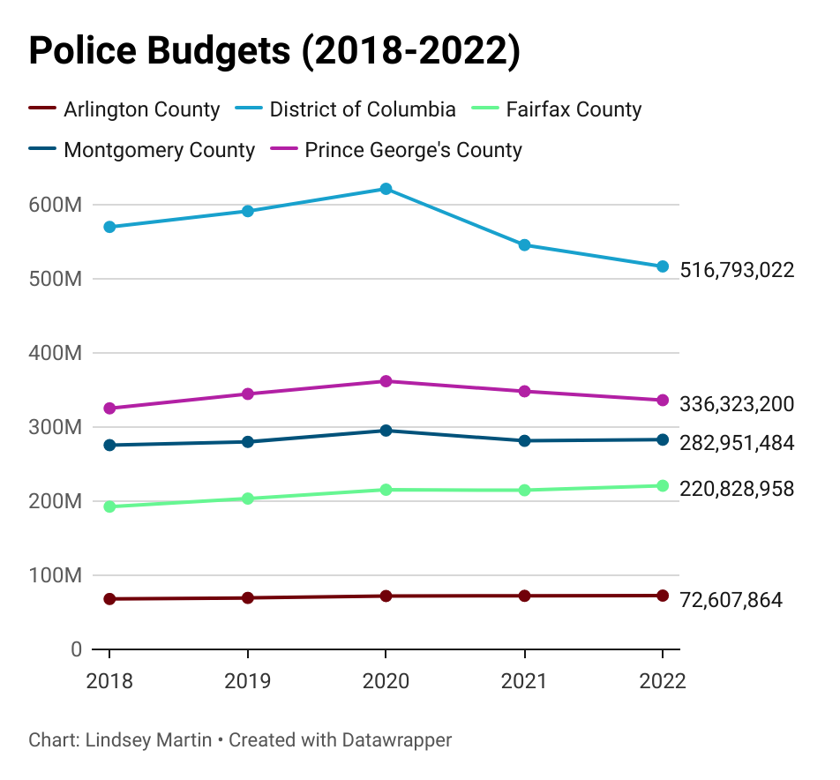

Police budget trends in the DMV, 2018-2022.

Notably, despite the sharp decline in funding, the D.C. Metropolitan Police Department continues to have the highest budget budget at over twice the amount of three of the five local jurisdictions analyzed, yet the District has the fourth lowest population size of the jurisdictions at roughly 692,000 residents.

All jurisdictions have seen decreased funding over the last two budget cycles, indicating perhaps calls to defund the police have had some effect on the priorities funded by jurisdictions. Calls to defund have come into immense prominence over the last two years, following the killing of George Floyd by Minneapolis police in June 2020, just before the District of Columbia began their annual budget process.

However, calls to reform policing did not start in 2020. Advocacy around this issue has been increasing in prominence since 2014, after the killing of Michael Brown by police in St. Louis spurred the initial rise of the Black Lives Matter movement.

Alongside these calls has also been an economic crisis brought on by the COVID-19 pandemic that has constrained government budgets across the nation and prompted workforce shortages across sectors.

Members of the D.C. Council found themselves at odds with Mayor Muriel Bowser’s police budget priorities this last cycle. The mayor’s $59 million budget proposal to boost MPD staffing and a co-responder model proposal took a massive cut prior to the final budget adoption for FY 2022.

DC Councilmember James Allen, Chair of the Judiciary and Public Safety Committee, led the council’s work in countering the mayor’s initial budget, which among other changes, slashed a $11 million proposal for new MPD officers down to $5 million.

Eliana Golding, Policy Analyst with the D.C. Fiscal Policy Institute, which conducts research and public education primarily around budget and tax issues in the District, says the D.C. government has not shown a commitment to defund the police:

“The decrease in MPD’s operating budget from 2021 to 2022 is due to officers leaving the force faster than MPD can recruit and hire, not a systemic effort to shift resources away from policing and to other needs,” she states.

It’s not enough, however, to look at the initial funding amount and assume a jurisdiction’s priorities. Take, for example, Fairfax County. When compared to D.C.’s MPD, the two jurisdictions seem to be polar opposites in the response to police funding. Fairfax County saw a steady 5% budget growth within the police department until 2021, when it saw a less than one percent decrease in overall budget, bolstered back with an almost 3% increase in 2022.

A review of where that money is being directed to once allocated to the police department offers a much clearer picture, indicating that perhaps MPD and FCPD are closer aligned than what overall budget trends would suggest.

Certainly, employee compensation and new positions received a large chunk of new funds over the years in Fairfax County. But a few unexpected new initiatives requiring additional funding have also progressively made an appearance within the FCPD budget. Primarily, millions of dollars in recent years could be attributed to body-worn cameras and funding to support the county’s “Diversion First” initiative, which trains officers to recognize a mental health crisis when an individual comes into contact with law enforcement, and works to divert these individuals from jail and towards mental health services.

An analysis of the cited items targeted with increases in Fairfax County’s police budget since 2018 revealed a strong emphasis on an increase in compensation, driving the majority of the overall budget’s steady increase for a few years before tapering off with the onset of COVID-19. However, the implementation of body-worn cameras for all FCPD officers has driven a multi-million dollar increase for the department as well in recent years, revealing a shift in priorities for the county.

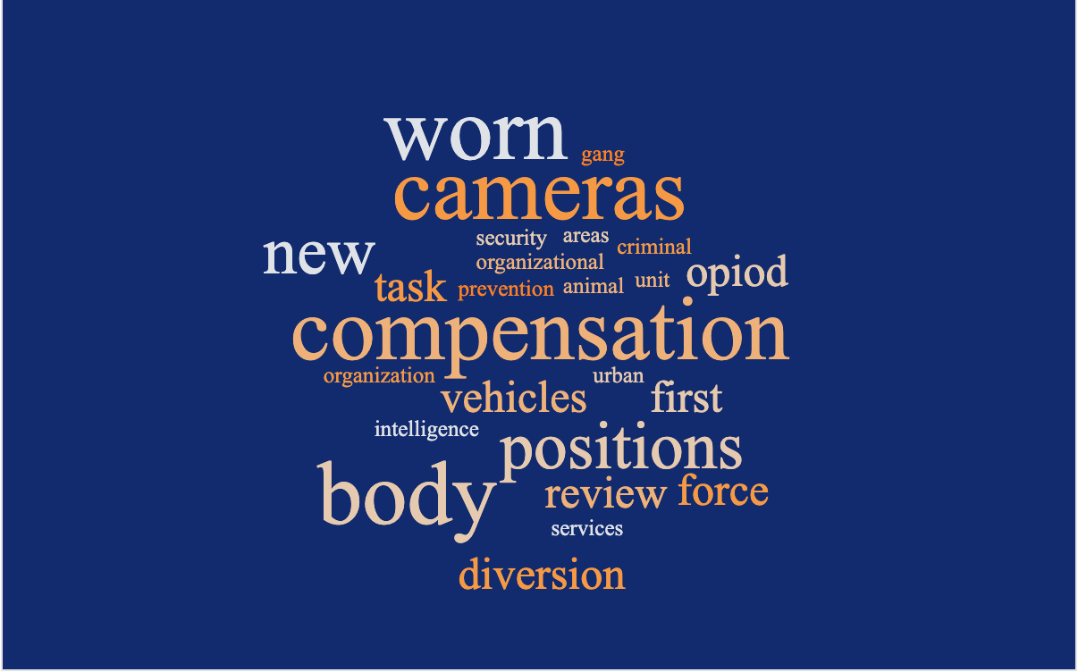

Word cloud of the most common areas of budget increases for Fairfax County police.

Anthony Guglielmi, Public Information Officer for the Fairfax County Police Department, says the FCPD budget has continued to grow in part with continued funding support for traditional police operations, but with added funding to support police reforms:

“In addition to funding the new station in Lorton, we have several training and mental health initiatives… including the co-responder model that we hope to implement during the next fiscal year,” Guglielmi says.

Fairfax County has seen its share of controversy and tragedy surrounding police actions, including the police shooting that killed unarmed county resident John Geer in his home in 2013 and the killing of Natasha McKenna while in police custody, prompting calls for police reform and leading to the creation of the [Ad Hoc Police Practices Review Commission](https://www.fairfaxcounty.gov/policecommission/) by then Board of Supervisors Chairman Sharon Bulova in 2015. The commission met over the course of two years before publishing a final report with recommendations for improving police accountability, transparency, and the police response to mental health crises.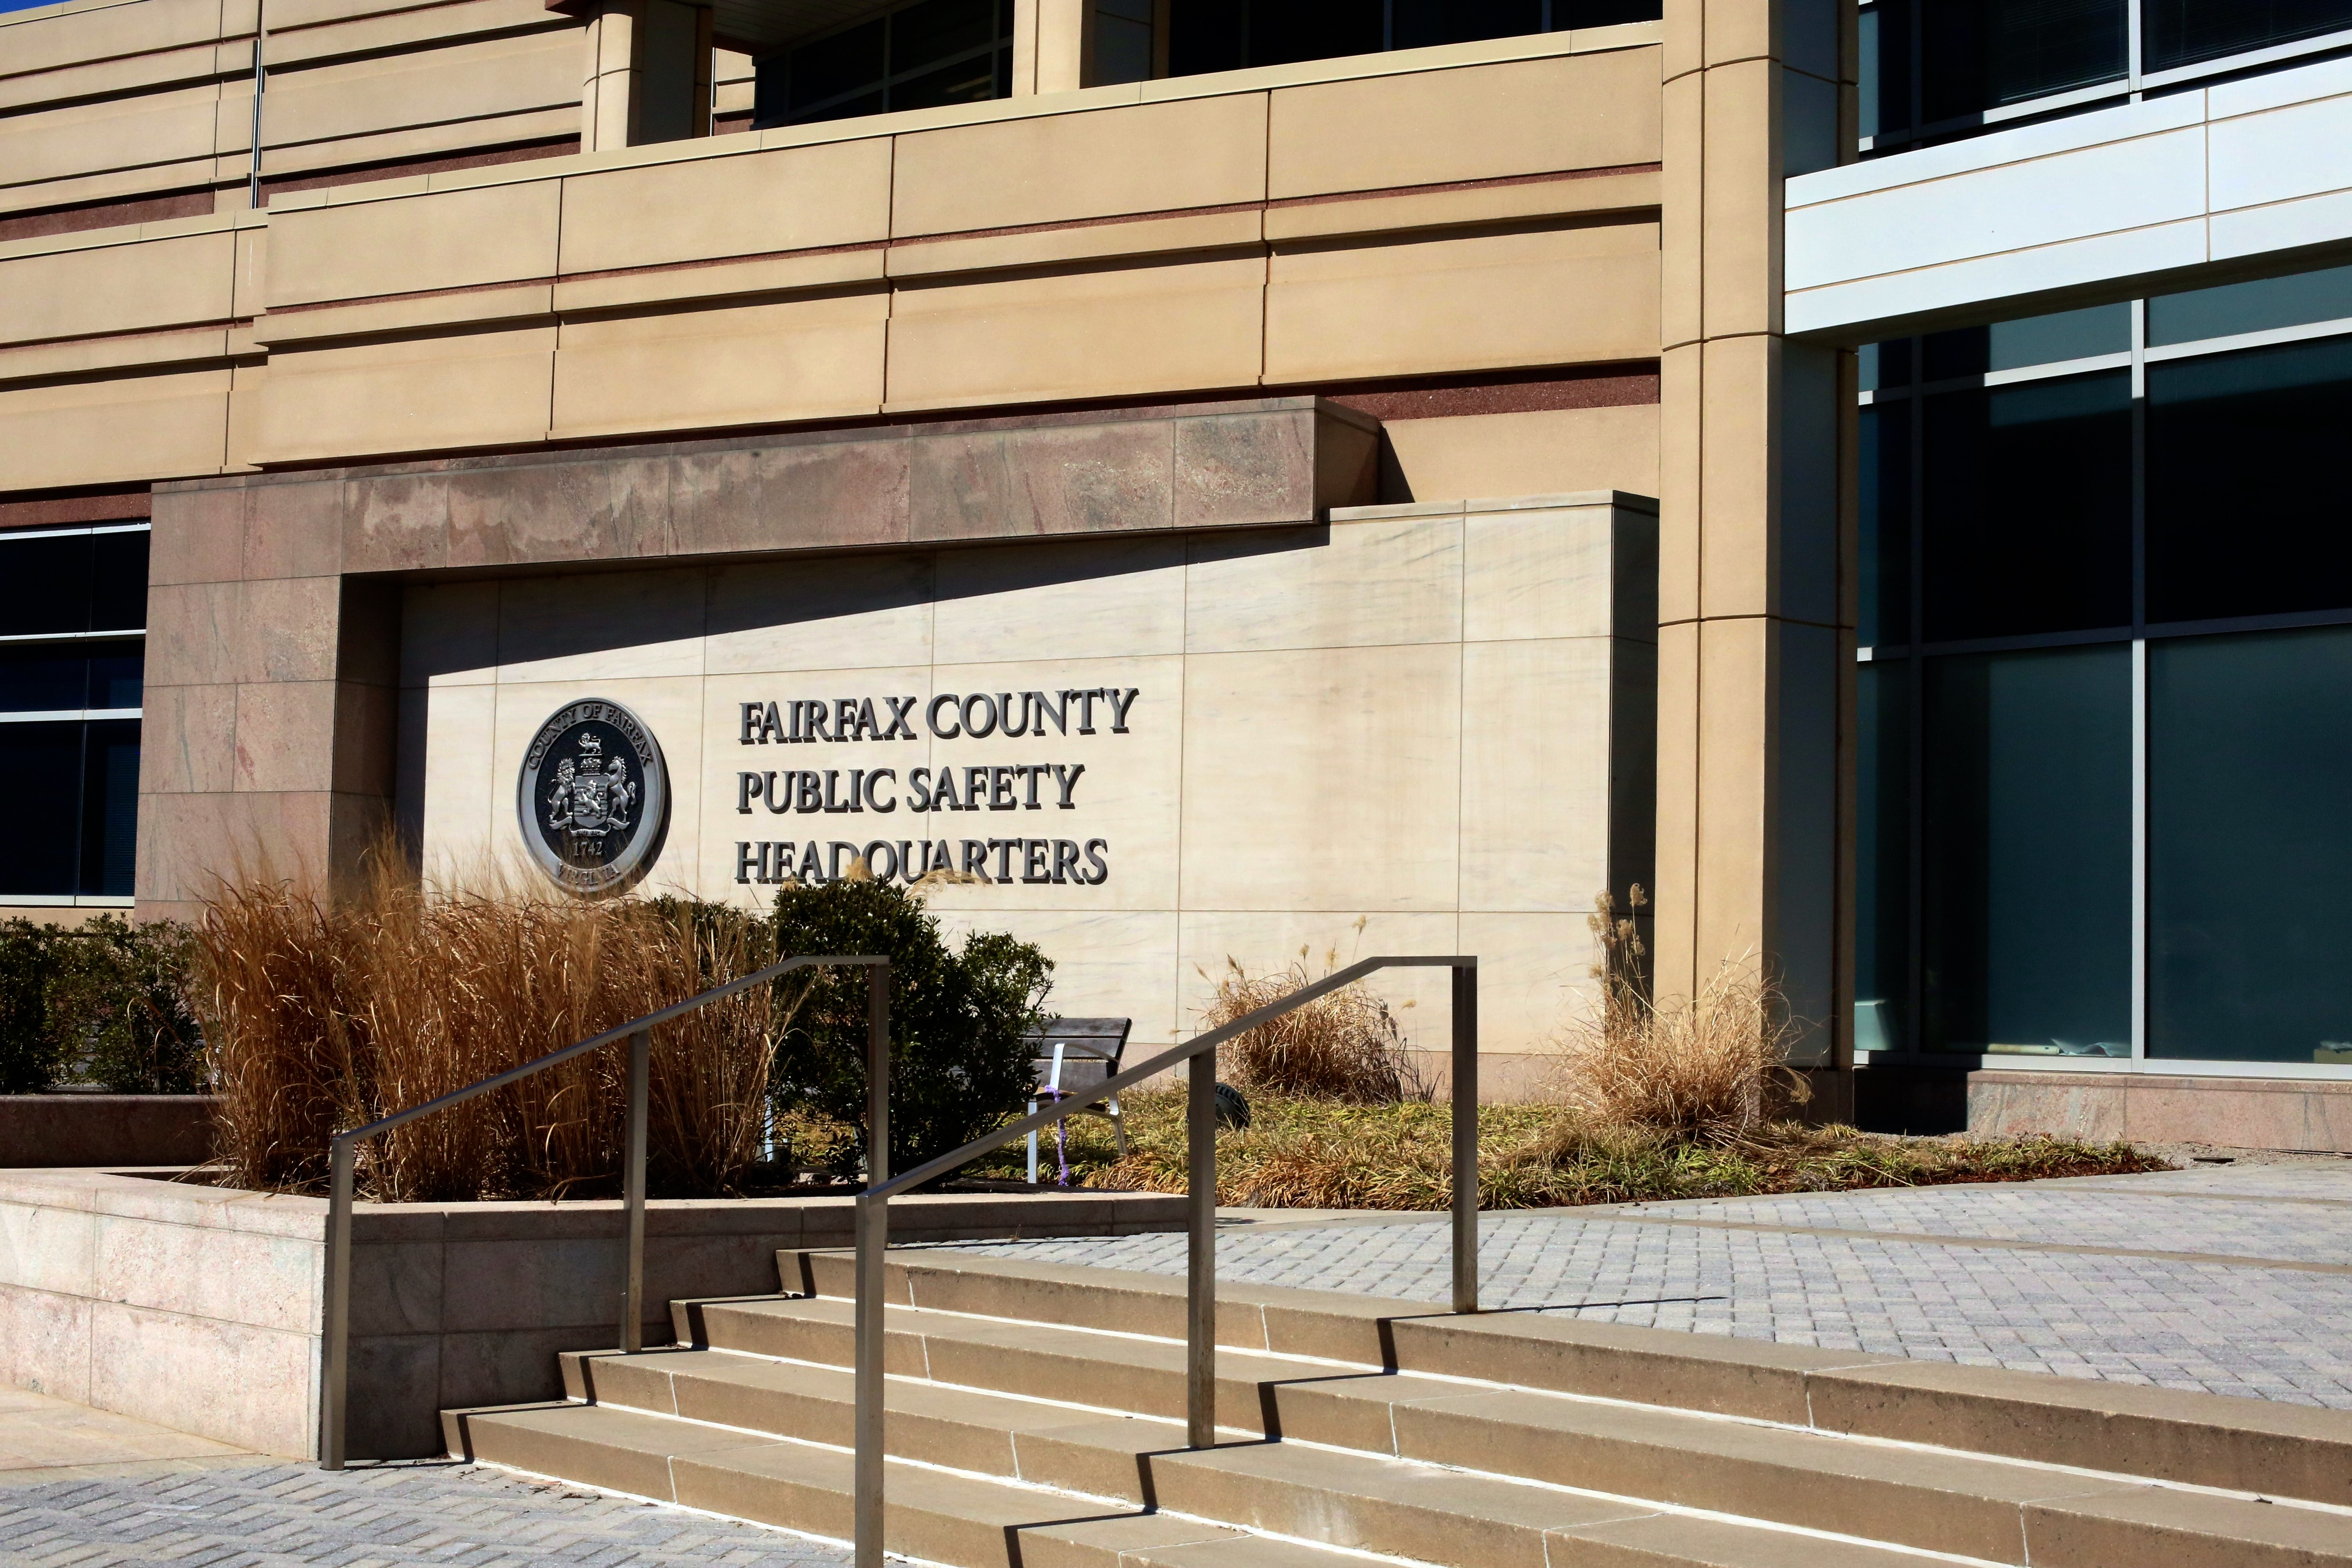

Recent years have continued to see an increased focus on select police reforms in Fairfax County, such as the set-up of the Police Civilian Review Panel, a citizen-led committee which investigates allegations of police misconduct.

Still, the county continues to invest in the growth and staffing capacity of its new South County police station located in Lorton, Virginia, and increasing police pay in the county continues to be a major advocacy point among supporters of the police during each budget season.

For the time being, it seems that localities in the Washington metropolitan area have yet to determine their approach to the future of policing. Instead, localities take a middle ground approach, focusing on a dual effort to increase funding into traditional areas for the police department alongside reforms including initiatives centered on mental health competency.

Instead of funding diverted from one area to another, localities opt to allow these competing interests to co-exist within police department budgets. While each jurisdiction makes its own tweaks, the end result is a gradual convergence of funding levels for police departments across the Washington metropolitan area.